1. **Row Level Security: -**

Go to My Work Space>> Select Dataset Security

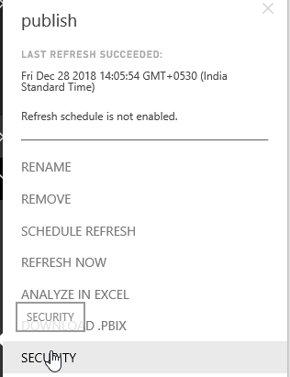

And then provide access according to requirements.

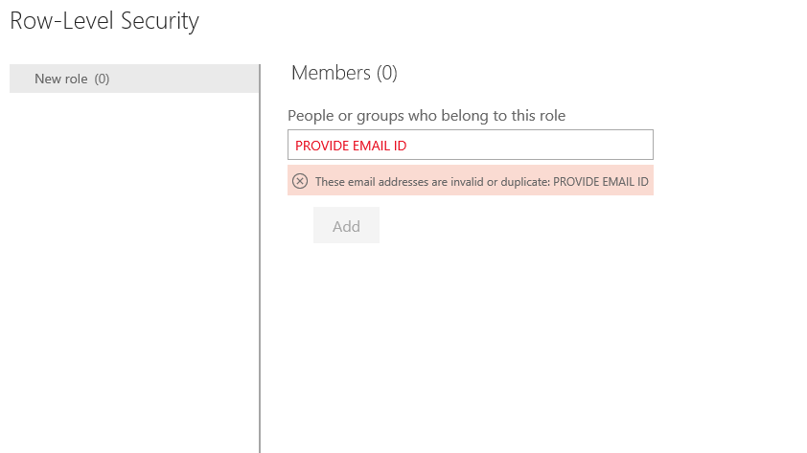

1. **How to download, Export and Print Report:**

Go to Report>>

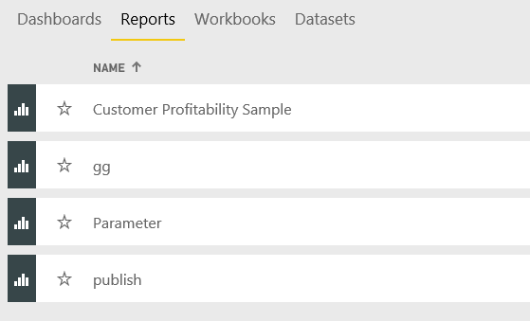

Select your report>>

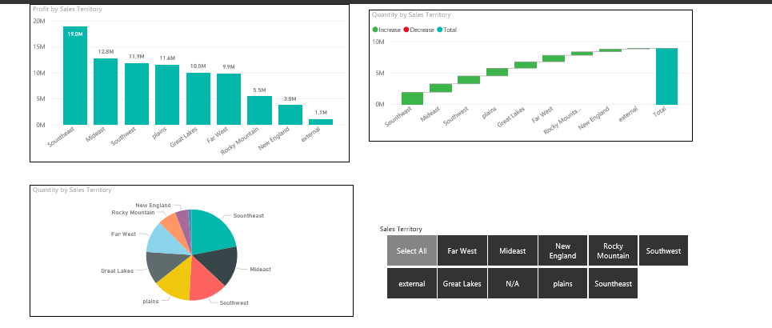

Then go to File Option and select download option:

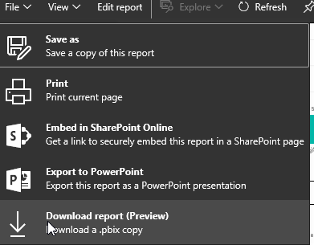

1. **How to share Report:**

Go to My Work space then click on Report and after that choose share option:



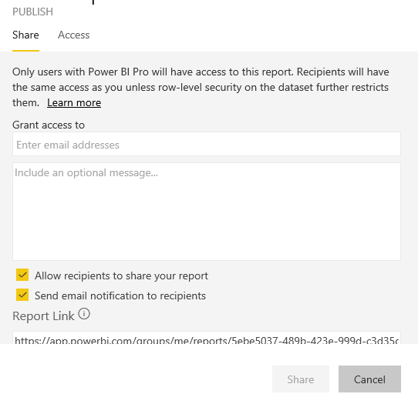

1. **If someone share report then where we can find:**

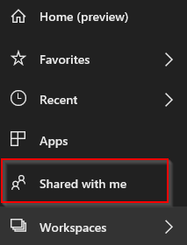

1. **Data Gateway: -**

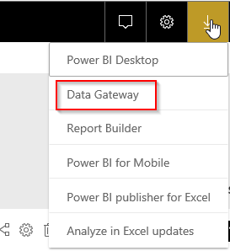

1. **Creating Work Space:**

Go to Workspace >> Click on 

1. **For Creation of Dataset , Dashboard, Report:**

Then go to right hand side of services and then click on :

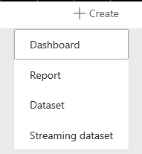

1. **Search Option:**

You must choose workspace and then search your reports, dashboards, workbooks or datasets

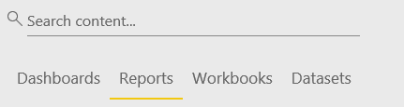

1. **How to Create Report on Services:**

Go to My Work space then click on Report:

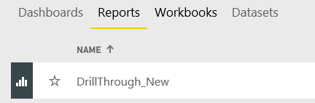

Then click on Report >> and then click on edit Report now you can play with it:

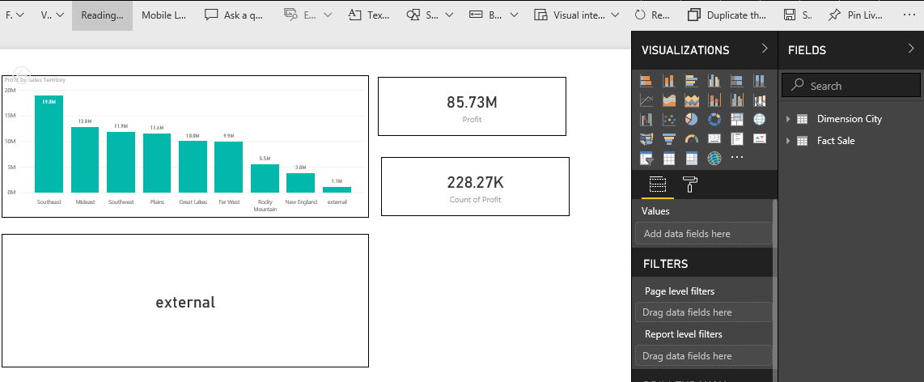

1. **Generate QR Code and Analyze in Excel:**

Go to My Work space then click on Report:

Then go to right hand side and click on 3 dots then you find below screen:

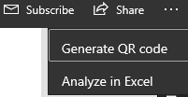

1. **Convert to Mobile Layout and Reading View:**

Go to My Work space then click on Report and then Select Mobile Layout:

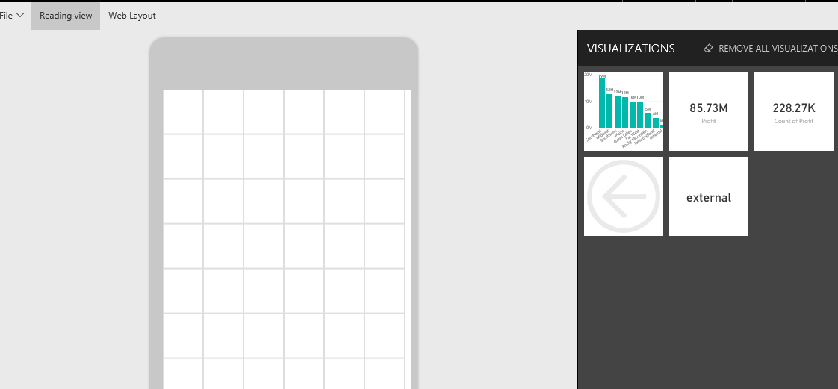

Go to My Work space then click on Report and then Select Reading View:



1. **Pin to Live Page (Dashboard):**

Go to My Work space then click on Report and then Select Pin Live Page:

And as per your requirement click on existing dashboard or New Dashboard:

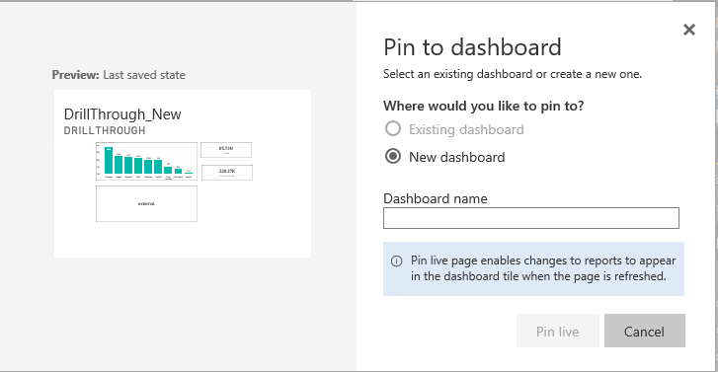

1. **Subscription:**

Go to my workspace then click on Dataset and then click on Setting:

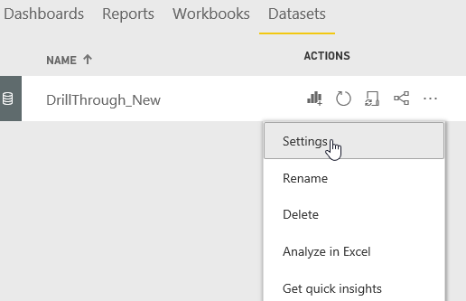

After that click on Subscription and check your subscriptions:

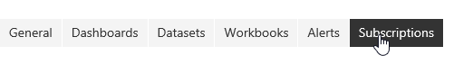

1. **Schedule Refresh:**

Go to my workspace then click on Dataset and then click on Setting and then select Schedule Refresh:

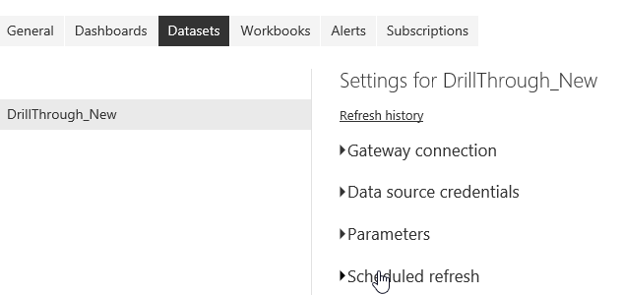

1. **View Related, Quick Insight, View Usage Metrics, And Delete Options:**

Go to my workspace then click on and then you can find all these options:

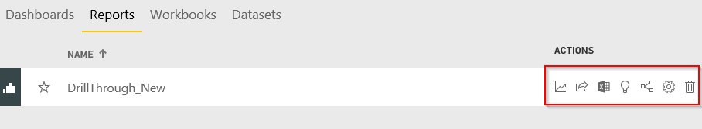

1. **Add Tile:**

Go to my workspace then click on Dashboard and Select ADD Tile Option:

